# Municipio de Smart (SMART MUNICIPALITY)

**Overview:**

'Municipio de Smart' is an integration of intelligent systems and smart applications in order to simplify the municipality administration and to ensure effective reporting. Intelligent systems sense the need of attention and alert the staff, where as Smart application eases the citizen to report any issue. A centralized system with municipality staff helps to aggregate all these issues and respond to them effectively.

**Intelligent Systems:**

These systems do not require manual intervention to do their job. These are meant to be deployed across the city along with the

* Garbage bins
  + To sense the need of garbage collection and reports to centralized system.
* Drainages
  + To detect the drainage blocks in advance and alert the staff.
* Road side landscaping
  + To help the city go green by identifying the need of water to plants and reporting the same. This is done by detecting the lower moisture levels in the sand.

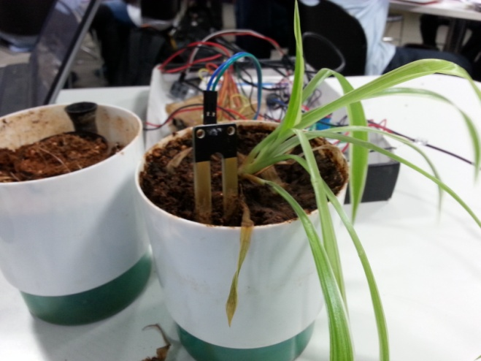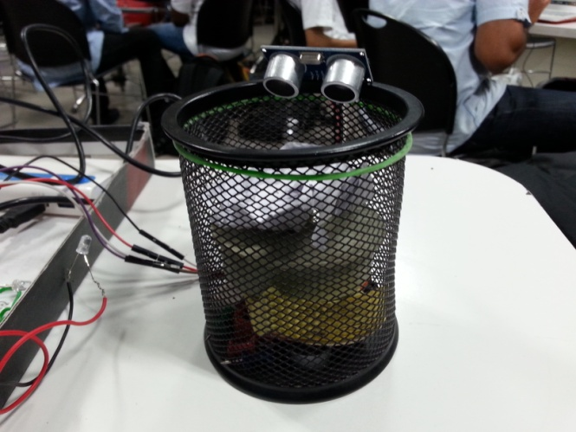

**Smart application:**

This is for the citizens of the city to report any incident/issue to municipality such as potholes, animal carcass, pipe leakages etc. It can be done just by couple of clicks and user can take a picture of the issue and attach it to the report.

Features of the application:

* Ease of use.
* Track/analyze the activity of the staff in resolving the issue and citizen who reported is entitled to receive the updates on it till the issue comes to the closure.
* Can be accessible via tablet, smart phone as well as system.
* Location of the issue will be automat ically sent via report, though optional to use this feature.

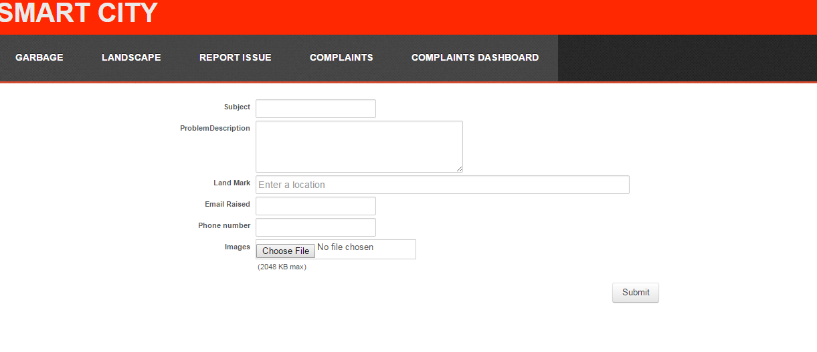

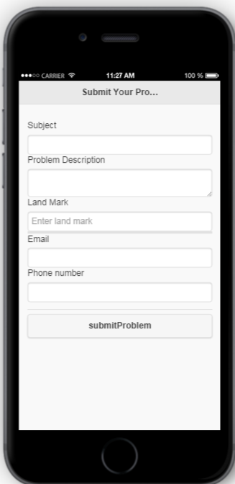

**Centralized system:**

This system is made for the municipality administration where all the issues (reported by intelligent systems and citizens across the city) get pinned on the map based on their location along with the description. This will help the staff

* To prioritize the issues
* To group the issues with respect to region.
* To trace the progress and age of the issue.
* To get the quick analysis and trends of the issues.

